Nine Events of Instruction
One useful tool you can use to develop your Lesson Plans is Robert Gagne’s Nine Events of Instruction.
Robert Gagné proposed a process for instruction that engages learners. As we saw in the Lesson Planning webinar, there are nine events that Gagné included in the process of instruction. Here are some important things to remember about the Events of Instruction:
- While this is primarily a linear process, the sequence is not always one after another.
- Some events will happen multiple times during a lesson!
- Sometimes multiple events can be covered by a single activity, or some events occur simultaneously (such as performance and feedback).

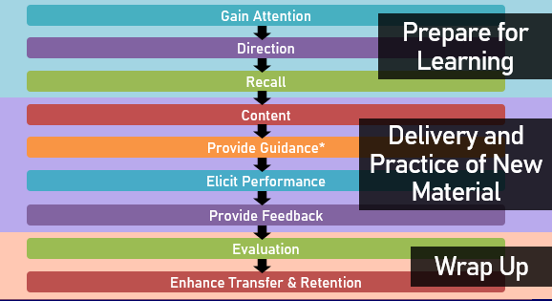
Figure: Gagne's Nine Event of Instruction Sequence
We can group the events into three different phases to better understand how they fit into training delivery.
- The first phase is Prepare for Learning. During this phase you typically include the gain attention, direction and recall events.
- Once you prepare the learners, you enter the second phase, Delivery and Practice of New Material, where you present the content, provide guidance, elicit performance and provide feedback on that performance.
- Finally, the third phase is the Wrap Up, which consists of the assess performance and enhance retention and transfer of learning.

Gagne’s Nine Events of Instruction
- The first step is to Gain Attention. This is related to the subject matter yet does not teach new material. This is vital in getting the learner to engage in the topics and subject matter that they will be taught. Once you have the learner’s attention you can begin moving forward in the process.
- Give them Direction by stating what learning objectives they will accomplish during the instruction. Share your Learning Objectives clearly, and as needed during a lesson.
- Recall previous Knowledge and Skills occurs to give learner(s) the opportunity to remember and build upon the previous content with upcoming new knowledge and context. This recall also acts as a double check that learners meet the prerequisites for the course.
- Present Content. You present new information relevant to the learners in an organized manner, makes logical sense and is progressive.
- Provide Guidance for your learners through the use of learning activities for your learners to get directly involved with the content and skills.
- Elicit Performance by having your learners apply newfound skills and/or knowledge. This can be done in many different ways, but often done through learning activities and skills application.
- Provide (constructive) Feedback based on the learner’s attempt(s) to demonstrate their new skills. Offer positive feedback and provide specific suggestions to improve rather than just saying “good job”.
- In order to do this, you Assess your Learners’ Performance. Learners must be evaluated based on the objectives outlined in the Direction phase of the lesson. This can be done through tests/quizzes and knowledge checks. However, evaluation does not always need to be a formal, graded product.
- Enhance Retention and Transfer is the last step to support learners to internalize any information and ensure the learner understands what was covered in the lesson. Ways to do this are: to summarize/paraphrase content, have practice training, learner demonstrations, and offer additional materials to use after the lesson (job aids, one-pagers, schematics, maps, templates, etc.).

Instruction Event | Method of Delivery | Activity
Gaining Attention | PPT/Exercises/Props & Materials | Share a Story, Show a Video  Teaching stations/Whole group discussion/ Icebreaker
Give Direction | PPT/Questions/Forms | Be Clear How Content is Relevant  Course Goals and Objectives, Lecture/Handouts/Agenda
Recall | PPT/Assessments or quizzes | Reflect on Life Experience and Related Knowledge  Individual or whole group discussion, Self-Assessment, Knowledge Check
Present Content | PPT/Lecture/Demonstration/  Exercises/Videos/Hands-on | Keep Delivery Varied  Learning activities/Handouts/Writing notes/Discussions/Troubleshooting
Provide Guidance | Exercises/Discussion/Learning activities/Hands-on | Engage Learners for Understanding  Whole group, small group or individual activity or discussion/Rotating flip charts
Elicit Performance | Assessments or quizzes/Demonstrations/  Hands-on/Exercises | Test the New Skills and Knowledge  Mock presentation/Troubleshooting attempts/Tests
Provide Feedback | Demonstration/Discussion/  Assessments | Stay Constructive and Positive  Discussions/Handouts/Peer Review
Assess Performance | Assessments or quizzes/Discussion/Hands-on | Check in on Learning and Application  Whole group discussion/Rubrics/Troubleshooting
Enhance Retention and Transfer | Hands-on/Demonstration/  Videos/Exercises | Keep Knowledge Fresh  Discussions/Troubleshooting

The table shown above lists each step of Gagne’s events and possible delivery methods for learners, what to keep in mind, and several examples of activities you can incorporate to have each event occur in your lesson.

