Lesson Plan: Basics

When creating any sort of instruction, always create some kind of lesson plan – this plan will be a roadmap to take you from one location to your destination.
Developing an effective, thoughtful lesson plan (with checklists
and needed materials) is a core part of your preparation.

So, what is a lesson plan?
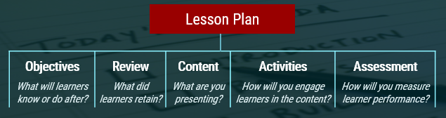
A typical lesson plan is a structured outline that maps and describes the methods and outcomes of your lesson(s). This includes general descriptions of the goals, learning objectives and the means to achieve them (instructional methods), as well as the sequencing and timing for each section and activity. Another way to think of it is as an instructor’s road map of what learners need and how your objectives for instruction will be achieved.
Figure: Example Lesson Plan Sections
Lesson Plan Components
A lesson plan (generally) has at least 5 major components:
- Objectives – what knowledge learners will acquire and apply from the lesson.
Example Objective – Learners will fully understand and be able to demonstrate proper use of required safety equipment at 100% accuracy (by the completion of this lesson).
- Review - what did learners retain previously through experience, including prerequisite knowledge
- Content - what material you are presenting; can include steps, or a checklist to complete
- Activities - how you engage learners with content, use of new skills (application), and instructor evaluation & feedback
- Assessments - how you measure learner mastery, performance and growth

Lesson Plan Tool: Preparation
Preparation is vital for designing and delivering any successful lesson. Before you deliver a lesson, ensure you:

- Know your environment and audience, and plan accordingly
- Define clear objectives, learner outcomes and levels of mastery
- List all materials needed (for the lesson and activities)
- Map out your lesson timing (as best as you can)
- Define and have all materials (for your training environment),
- Determine all steps for your activity or hands on exercise
- Decide how you will evaluate mastery; create your assessments
- Practice your delivery!

Lesson Plan Tool: The Checklist
Checklists can serve as a core reference or preparation tool for instructors prior to their class instruction or activities/exercises. Consider the following points when creating and using a Lesson Plan activity or hands-on exercise checklist:
- Identify the skill or task
- Prepare a clear statement to introduce the task
- State the objective(s) to performing this task
- List the steps to accomplish the task
- Review/explain the steps needed for a learner to perform the task.
- Be able to clearly state and demonstrate mastery of the skill or content

